**DHT-22 Sensor Data in Smartphone using HC-05 and Arduino**

**Object:** In this project we are going to demonstrate you how we can see the humidity and temperature of our environment in our smartphone in real time using HC-05 bluetooth module.

**Hardware Used**:

* Arduino Uno
* HC-05 Module
* DHT22 sensor
* Jumper wires
* 10k resistor

**Software Used:**

* Arduino IDE
* Bluetooth Terminal for getting data in smartphone

**Circuit diagram:**

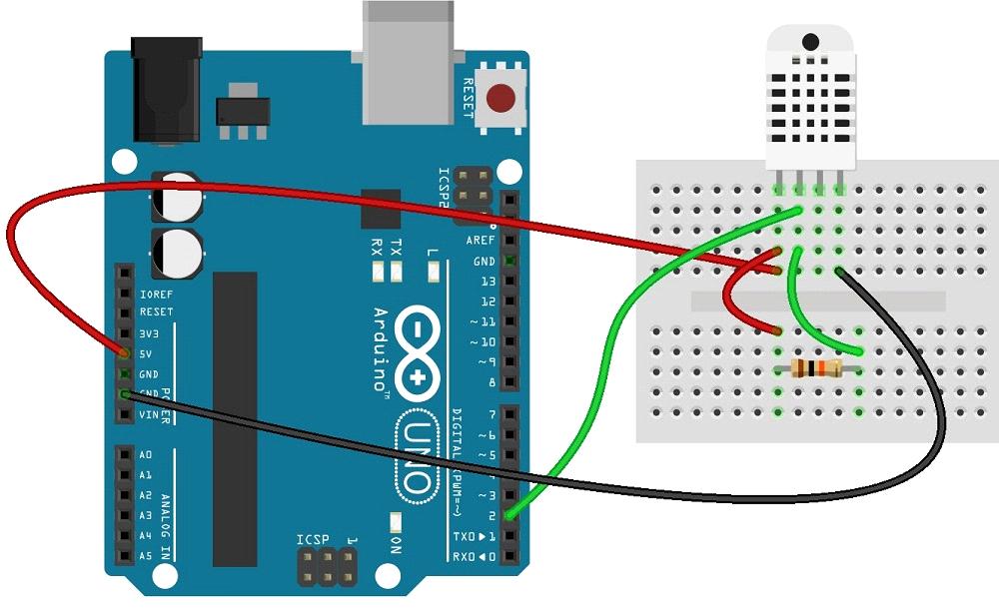

**Fig1: connection of Arduino UNO with DHT22**

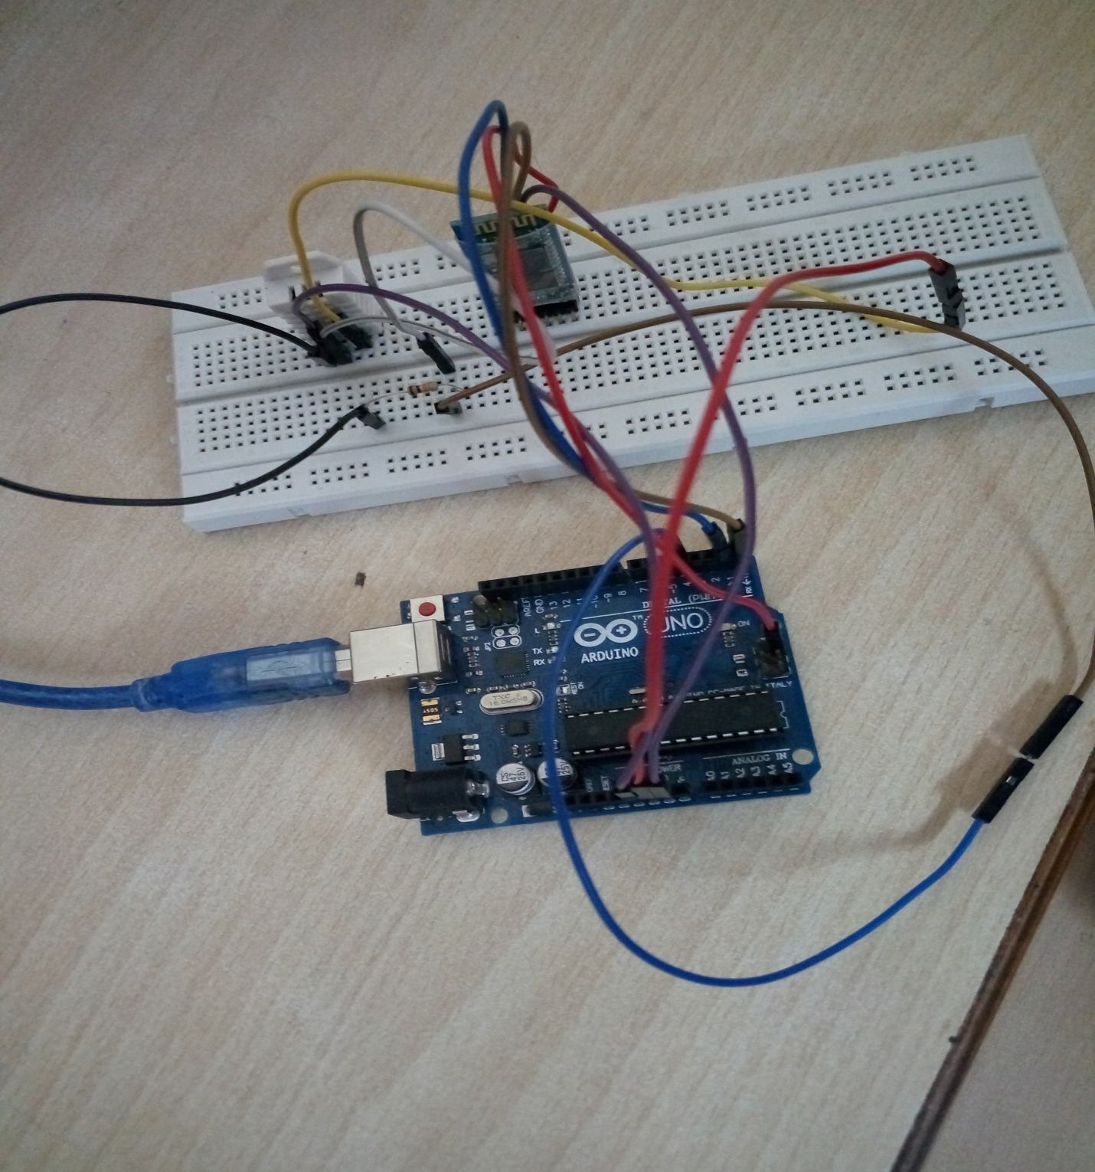

**Fig2: Arduino with DHT22 and HC-05 Bluetooth Module**